A
INDUSTRIAL ORIENTED MINI PROJECT
ON
START UP FUNDING DASHBOARD
SIDDHARTHA INSTITUTE OF TECHNOLOGY & SCIENCES
(UGC – AUTONOMOUS)
(Approved by AICTE, New Delhi & Affiliated to JNTUH, Hyderabad) Accredited by NBA and NAAC with 'A+' Grade.
Narapally, Korremula Road, Ghatkesar, Medchal-Malkajgiri (Dist.)-500088


(Submitted in partial fulfilment of the academic requirements of B.Tech) In

DEPARTMENT OF CSE (DATA SCIENCE)

By

P.SANTHOSH SHARMA(23TQ1A6710) CH.RASHMITHA (23TQ1A6748)
SHAIK SAMEER (23TQ1A6723)

Under the Esteemed Guidance of

Mr.K.VIJAY
Assistant Professor, Department of CSE (Data Science


SIDDHARTHA INSTITUTE OF TECHNOLOGY AND SCIENCES
(UGC – AUTONOMOUS)
(Approved by AICTE, Affiliated to JNTU Hyderabad, Accredited by NAAC(A+)) Korremula Road, Narapally(V), Ghatkesar Mandal, Medchal-Dist:-500088

CERTIFICATE
This is to certify that the project report entitled
START UP FUNDING DASHBOARD
being submitted by

P.SANTHOSH SHARMA(23TQ1A6710) CH.RASHMITHA (23TQ1A6748)
SHAIK SAMEER (23TQ1A6723)

In partial fulfilment for the award of the degree of Bachelor of Technology in Computer Science and Engineering (Data Science), Jawaharlal Nehru Technological University Hyderabad, is a record of bonafide work carried out under my guidance and supervision. The results embodied in this Mini Project report have not been submitted to any other University or Institute for the award of any Degree or Diploma.

Guide  Mr.K.VIJAY  Dept. of CSE(DS) | Co-Ordinator  Mrs. R. SHIRISHA  (Assistant Professor) | Head of Department  Mr. K. VIJAY  Dept. of CSE(DS)

Internal Examiner External Examiner

DECLARATION

We declare that this project report titled START UP FUNDING DASHBOARD
submitted in partial fulfilment of the degree of B.Tech in CSE (DATA SCIENCE) is a record of original work carried out by us under the supervision of Mr. P. SRINU and has not formed the basis for the award of any other degree or diploma, in this or any other Institute or University. In keeping with the ethical practice in reporting scientific information, due acknowledgments have been made wherever the findings of others have been cited.

BY
P.SANTHOSH SHARMA(23TQ1A6710) CH.RASHMITHA (23TQ1A6748)
SHAIK SAMEER (23TQ1A6723)

ACKNOWLEDGEMENT
Any endeavor in the field of development is a person’s intensive activity. A successful project is a fruitful culmination of efforts by many people, some directly involved and some others who have quietly encouraged and supported.
Salutation to our beloved and highly esteemed institute SIDDHARTHA INSTITUTE OF TECHNOLOGY AND SCIENCES for grooming us into Computer Science and Engineering (Data Science) graduates. We wish to thank PRINCIPAL Dr. M. JANARDHAN VICE PRINCIPAL DR.G.PRAVEEN KUMAR for providing a great learning environment.
We wish to express profound gratitude to Mr. K. VIJAY, Assistant Professor and HEAD OF DEPARTMENT, CSE (DATA SCIENCE), for his continuous encouragement to ensure successful results in all our endeavors.
We would like to thank Mr. K. VIJAY Department of CSE (DATA SCIENCE), who patiently guided and helped us throughout our project.
We take this opportunity to thank the department’s Project Review Co-Ordinator Mrs. R. SHIRISHA for all the review meetings, suggestions, and support throughout the project development.
BY
P.SANTHOSH SHARMA(23TQ1A6710) CH.RASHMITHA (23TQ1A6748)
SHAIK SAMEER (23TQ1A6723)

ABSTRACT

Startup funding plays an important role in the growth and development of new businesses. Startups require financial support at different stages, such as launching a product, expanding operations, hiring employees, developing technology, and entering new markets. However, startup funding data is usually available in large and unorganized datasets, making it difficult to understand funding patterns, investment trends, investor preferences, and the performance of different startups. The Startup Funding Dashboard is developed to provide an interactive and easy-to-understand platform for analyzing startup funding data.
The dashboard collects and analyzes important information such as startup names, industries, funding amounts, funding stages, locations, investors, and funding dates. The collected data is processed and presented through different charts, graphs, tables, and interactive visualizations. Users can analyze the total funding received by startups, identify industries that attract higher investments, compare funding across different years and locations, and understand the participation of various investors. The dashboard also helps in identifying trends in startup funding and provides a clear overview of how investments are distributed across different sectors.
The main purpose of this project is to transform raw startup funding data into meaningful and useful information. Instead of manually analyzing large datasets, users can use the dashboard to quickly filter, compare, and explore the required information. The interactive nature of the dashboard makes it useful for students, researchers, entrepreneurs, investors, and business analysts who want to understand the startup funding ecosystem.
The Startup Funding Dashboard uses data analytics and visualization techniques to support better decision-making. By presenting complex funding information in a simple visual format, the system helps users identify important patterns and trends. Overall, the project provides an efficient and user-friendly solution for exploring startup funding data and understanding the factors and trends associated with startup investments.

TABLE OF CONTENTS
SECTION PAGE NO.
Certificate II
Declaration III
Acknowledgement IV
Abstract V
Table of Contents VI
Chapter 1: Introduction 7
  - Problem Statement 8
  - Objectives of the Project 9
  - Scope of the Project 10
Chapter 2: Literature Survey 11
Chapter 3: System Architecture 12
Chapter 4: Methodology 14
Chapter 5: System Requirements (Hardware & Software) 16
Chapter 6: Tools and Technologies Used 17
Chapter 7: System Design 19
Chapter 8: Uml Diagrams 21
Chapter 9: Source Code 24
Chapter 10: Results / Output / Screenshots 27
Chapter 11: Testing and Validation 29
Chapter 12: Advantages 31
Chapter 13: Applications 33
Chapter 14: Future Scope 34
Chapter 15: Conclusion 36
References / Bibliography 37
Appendix 39

Introduction

The startup ecosystem has grown rapidly in recent years, with new companies emerging in areas such as technology, healthcare, finance, education, e-commerce, transportation, and artificial intelligence. To establish and expand their businesses, startups often depend on funding from venture capital firms, angel investors, private investors,As the number of startups and investment activities increases, a large amount of funding-related data is generated. This data contains information about startups, funding amounts, investment stages, investors, industries, locations, and dates. Although this information can provide valuable insights, analyzing it manually can be difficult and time-consuming. Raw data may contain thousands of records, making it challenging to identify which industries receive the highest funding, which locations have more startup activity, which startups receive significant investments, and how funding trends change over time.
Data visualization provides an effective way to solve this problem by converting large amounts of numerical and categorical information into visual representations. Charts, graphs, tables, and filters allow users to understand data more quickly and easily. A dashboard combines these visualizations into a single platform, allowing users to interact with the data and obtain useful information according to their requirements.
The Startup Funding Dashboard is designed to analyze startup investment data and present the results in an interactive format. The dashboard can display important Key Performance Indicators (KPIs), such as total funding, number of startups, number of investors, and average funding amount. It can also provide visualizations showing funding trends by year, industry-wise funding, location-wise funding, funding-stage analysis, and investor contribution.

7

Problem Statement
Startup funding data is often available in the form of large datasets containing information about companies, investors, funding amounts, industries, locations, and investment dates. Although this data contains valuable information, it is difficult for users to understand overall funding landscape by simply looking at raw records. Manually analyzing such large datasets requires considerable time and effort and may make it difficult to identify important trends and relationships.
One of the major problems is the lack of a simple and centralized platform for analyzing startup fundin information. Users may need to examine different records separately to determine which startups have received the highest funding, which industries attract more investment, and which locations have greater startup activity. Without proper visualization, comparing these values and identifying patterns becomes difficult.
Another problem is that funding trends can change over different periods of time. It may be difficult to determine whether startup investments are increasing or decreasing, which years experienced higher funding activity, and which funding stages received the most investment. Similarly, investors may focus on specific industries or geographical regions, but these patterns are not always easy to identify from raw data.
Therefore, there is a need for an interactive Startup Funding Dashboard that can collect, process, analyze, and visually represent startup funding data in a simple and meaningful manner. The proposed system aims to solve this problem by providing interactive charts, graphs, KPIs, tables, and filtering options. It allows users to quickly analyze funding patterns, compare different categories, identify major investment trends, and obtain useful insights from the available startup funding data.

Objectives of the Project

The main objective of the Startup Funding Dashboard is to develop an interactive and user-friendly dashboard that helps users analyze and understand startup funding data effectively.

The specific objectives of the project are:
- To analyze startup funding data by studying information such as startup names, industries, funding amounts, funding stages, investors, locations, and funding dates.
- To visualize funding information using different charts, graphs, tables, and Key Performance Indicators (KPIs), making complex data easier to understand.
- To identify funding trends by analyzing how startup investments change over different years and time periods.
- To compare funding across different industries and identify which sectors receive higher levels of investment.
- To analyze geographical funding patterns and understand which cities, states, or countries have higher startup funding activity.

Scope of the Project

The scope of the Startup Funding Dashboard is to provide an interactive platform for analyzing and visualizing startup funding data in a simple and understandable manner. The project focuses on collecting, processing, analyzing, and presenting funding-related information through charts, graphs, tables, and key performance indicators. It helps users understand the overall startup investment environment without requiring them to manually analyze large datasets.
The dashboard covers important details such as startup name, industry, funding amount, funding stage, investor, location, and funding date. Users can analyze the total amount of funding received by startups and compare investments across different industries, locations, funding stages, and time periods. The dashboard can also help identify startups that have received significant funding and investors who have made major contributions to the startup ecosystem.
The project includes data cleaning and preprocessing to improve the quality and consistency of the funding dataset. Missing values, duplicate records, incorrect formats, and unnecessary information can be handled before performing the analysis. The processed data is then used to generate meaningful visualizations and insights.
The project also focuses on identifying funding trends and patterns. Users can understand how funding changes over time, which industries attract more investment, which locations have greater startup activity, and which funding stages receive higher amounts of investment. These insights can help users gain a better understanding of the startup funding ecosystem.
The scope of the project can be extended in the future by incorporating real-time funding data, advanced predictive analytics, machine learning techniques, investor recommendation systems, and automated data updates. Additional features can also be added to provide deeper analysis of startup performance and investment opportunities.

LITERATURE SURVEY

Startup funding has become an important area of study because startups require financial support for business development, product development, hiring employees, and market expansion. Previous studies have analyzed startup funding data using factors such as funding amount, industry, location, funding stage, investors, and funding date. These studies help in understanding the growth of startups and identifying the factors that influence investment decisions. Historical funding data can also be used to identify trends and patterns in the startup ecosystem.
Data analytics and Business Intelligence (BI) techniques are widely used for analyzing financial and investment-related data. Researchers have used data processing and analytical methods to calculate total investments, average funding, industry-wise funding, and changes in funding over different time periods. These techniques help reduce manual analysis and convert large amounts of raw data into meaningful information. The use of BI tools also helps investors, entrepreneurs, and business analysts make better data-driven decisions.
Data visualization plays an important role in presenting startup funding information in an easy-to-understand format. Charts, graphs, tables, KPI cards, and interactive filters can be used to represent complex funding data visually. Previous dashboard-based systems have shown that interactive visualizations allow users to compare different industries, funding stages, investors, locations, and years more effectively. Such dashboards make it easier to identify major funding trends, highly funded sectors, and important investment patterns.
From the existing studies, it can be observed that there is a need for a simple and centralized system that combines different aspects of startup funding analysis in one platform. The proposed Startup Funding Dashboard addresses this need by integrating data preprocessing, analysis, visualization, KPIs, and interactive filtering.

SYSTEM ARCHITECTURE

The Startup Funding Dashboard is designed using a five-layer system architecture. Each layer performs a specific function and works together to convert raw startup funding data into meaningful visual insights.

1 .Data Source Layer
The Data Source Layer is the first layer of the system. It contains the raw startup funding dataset collected from available sources. The dataset includes information such as startup name, industry, funding amount, funding stage, investor, location, and funding date. This layer provides the basic data required for further processing and analysis.

2. Data Preprocessing Layer
The Data Preprocessing Layer prepares the raw data for analysis. In this layer, missing values, duplicate records, incorrect data formats, and unnecessary columns are identified and handled. Data is cleaned and organized into a suitable format so that accurate analysis and visualization can be performed.

3. Data Analysis Layer
The Data Analysis Layer performs different calculations and analytical operations on the cleaned dataset. It calculates important values such as total funding, average funding, number of startups, number of investors, industry-wise funding, location-wise funding, and funding trends over time. This layer converts the processed data into useful information.

4. Visualization Layer
The Visualization Layer represents the analyzed information using different visual elements such as bar charts, line charts, pie charts, tables, KPI cards, and other graphs. These visualizations make it easier for users to understand funding patterns, compare industries, identify trends, and analyze investment distribution.

5. User Interface Layer
The User Interface Layer is the top layer through which users interact with the Startup Funding Dashboard. Users can view the KPIs, charts, tables, and other information and can apply filters such as year, industry, location, or funding stage. The interactive interface allows users to explore the data easily and obtain meaningful insights for better decision-making.

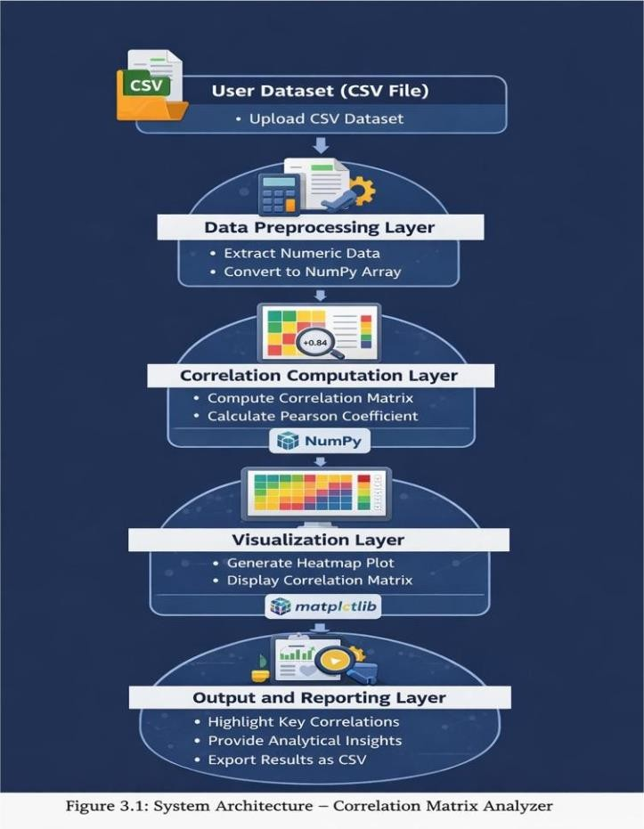

METHODOLOGY

Research Design
This project employs a quantitative analytical approach to explore relationships between variables within datasets. The methodology follows a structured Exploratory Data Analysis (EDA) workflow adapted from standard data mining practices. The approach focuses on statistical computation and visualization techniques to identify relationships between numerical features in datasets. The analytical process is implemented using Python-based numerical and visualization tools such as NumPy and Matplotlib.

Phase 1: Business Understanding
The initial phase focuses on defining the analytical objective of the system. The primary goal is to analyze relationships between variables within a dataset using correlation analysis. Understanding correlations between features is important in many data science tasks such as feature selection, dimensionality reduction, and model optimization.

Phase 2: Data Understanding
In this phase, the dataset uploaded by the user is examined and inspected to understand its structure and content. The dataset is provided in CSV format and may contain multiple columns representing different attributes.

Key activities in this stage include:

    - Loading the dataset from a CSV file using Python file handling techniques.
    - Extracting column headers that represent the dataset variables.
    - Identifying numerical attributes suitable for correlation analysis.
    - Determining the dataset dimensions, including number of rows and columns.
    - Inspecting sample data values to ensure correct data formatting.

This phase ensures that the dataset is properly understood before performing statistical computations.

Phase 3: Data Preparation
Data preparation involves a multi-step preprocessing pipeline:

Step 1: Dataset Reading

The CSV dataset is read and parsed to separate column names and data values. This ensures that the dataset structure is correctly interpreted.
Step 2: Numerical Data Extraction
The date_added column is converted from string to datetime format using pd.to_datetime(). Categorical columns are inspected for inconsistent casing or whitespace. The duration column is split into numeric_duration and duration_unit to enable quantitative analysis.
Step 3: Data Conversion
New features are derived from existing columns to enable richer analysis. year_added and month_added are extracted from date_added. month_name is derived from month_added for human-readable labels. A decade_added feature is computed to enable decadal trend analysis.
Step 4: Data Structuring
The dataset is organized into a matrix format where rows represent observations and columns represent variables. This structure is required for correlation matrix computation.

  - Phase 4: Correlation Analysis
In this phase, statistical calculations are performed to determine relationships between variables. The system computes pairwise correlations using the Pearson correlation coefficient, which measures the strength and direction of linear relationships between variables.

  - Phase 5: Visualization and Interpretation
Each analytical finding is evaluated for statistical significance and practical relevance. Visualizations are designed to clearly communicate each finding using the most appropriate chart type. Insights are extracted from each visualization and documented in narrative form.

  - Phase 6: Result Generation and Reporting
The final phase focuses on presenting the analytical results. The system outputs the computed correlation matrix, highlights highly correlated feature pairs based on a predefined threshold, and displays the heatmap visualization.

The correlation matrix can also be exported as a CSV file for further analysis or documentation. The final output provides users with meaningful insights into the relationships between variables in the dataset and supports further exploratory data analysis and machine learning workflows.

SYSTEM REQUIREMENTS (Hardware & Software)

Hardware Requirements
The following hardware specifications are recommended for executing the Correlation Matrix Calculator project effectively. Since the dataset contains approximately 8,807 records, the computational requirements are modest and can be met by most modern personal computers.

Component | Minimum Requirement | Recommended
Processor | Intel Core i3 / AMD Ryzen 3 (2.0 GHz) | Intel Core i5/i7 or AMD Ryzen 5/7 (2.5+ GHz)
RAM | 4 GB DDR4 | 8 GB DDR4 or higher
Storage | 10 GB Free Space (HDD) | 50 GB Free Space (SSD)
Display | 1024 x 768 Resolution | 1920 x 1080 (Full HD) or higher
GPU | Integrated Graphics | Dedicated GPU (optional)
Network | Broadband Internet (for download) | Broadband Internet (5 Mbps+)
Input Devices | Keyboard and Mouse | Keyboard, Mouse, and Trackpad
Table 5.1: Hardware Requirements

Software Requirements

Software / Tool | Version | Purpose
Operating System | Host environment | Windows 10/11, macOS 12+, Ubuntu 20.04+
Python | Primary programming language | 3.9 or higher
Anaconda Distribution | Python environment and package manager | 2022.05+
Jupyter Notebook | Interactive development environment | 6.4+ / JupyterLab 3.0+
NumPy | Numerical computing | 1.21.0+
Matplotlib | Data visualization (static plots) | 3.4.2+
Google Colab | Cloud-based alternative environment | N/A (browser-based)
Table 5.2: Software Requirements

TOOLS AND TECHNOLOGIES USED

Overview
This chapter describes the tools, technologies, programming languages, and libraries used in the development and implementation of the Correlation Matrix Analyzer project. The selection of these tools was based on their efficiency for numerical computation, data handling, and visualization tasks. Additionally, the technologies chosen are widely used in the data science community, making the project both practical and aligned with modern data analysis workflows.

Programming Language
Python 3.9+
Python is the primary programming language used for implementing the Correlation Matrix Analyzer. Python is widely recognized for its simplicity, readability, and extensive ecosystem of data analysis libraries. It enables developers to implement the complete data processing pipeline, including dataset loading, numerical computation, statistical analysis, and visualization within a single environment. The flexibility and strong community support of Python make it an ideal choice for data analytics and machine learning applications.

  - Data Processing and Numerical Computation
NumPy (Version 1.21.0+)
NumPy is the core numerical computation library used in this project. It provides efficient support for multidimensional arrays and matrix operations, which are essential for implementing correlation matrix calculations. NumPy enables fast mathematical computations such as mean calculation, covariance computation, and standard deviation operations required for calculating correlation coefficients.

CSV Module (Python Standard Library)
The built-in CSV module in Python is used for reading and parsing datasets stored in CSV format. This module enables the system to extract column headers and numerical values from datasets, allowing them to be processed for statistical analysis.

Visualization Libraries
Matplotlib (Version 3.4.2+)
Matplotlib is the primary visualization library used in the project. It is responsible for generating graphical representations of the correlation matrix in the form of heatmaps. The library provides extensive control over visualization parameters such as axis labels, titles, color scales, and annotations. Using Matplotlib, the project produces clear visual outputs that help users interpret relationships between dataset variables.

Development Environment
Jupyter Notebook / Google Colab
Jupyter Notebook provides an interactive development environment that allows code, visualizations, and narrative text to coexist in a single document. This facilitates iterative analysis and inline visualization, making it the ideal environment for exploratory data analysis projects.

Tools and Technologies Summary Table

Tool / Technology | Version | Role in Project
Python | 3.9+ | Primary programming language
NumPy | 1.21.0+ | Numerical computing and array operations
Matplotlib | 3.4.2+ | Static data visualization
Jupyter Notebook | 6.4+ | Interactive development & inline visualization
Anaconda | 2022.05+ | Python environment & package management
Google Colab | Browser-based | Cloud-based alternative execution environment

SYSTEM DESIGN

System Design Overview
The system design of the Correlation Matrix Analyzer focuses on providing a structured and efficient framework for performing correlation analysis on user-provided datasets. The system is designed to accept datasets in CSV format, process the data using numerical computation techniques, and generate meaningful insights through statistical analysis and visualization.

System Design Diagram
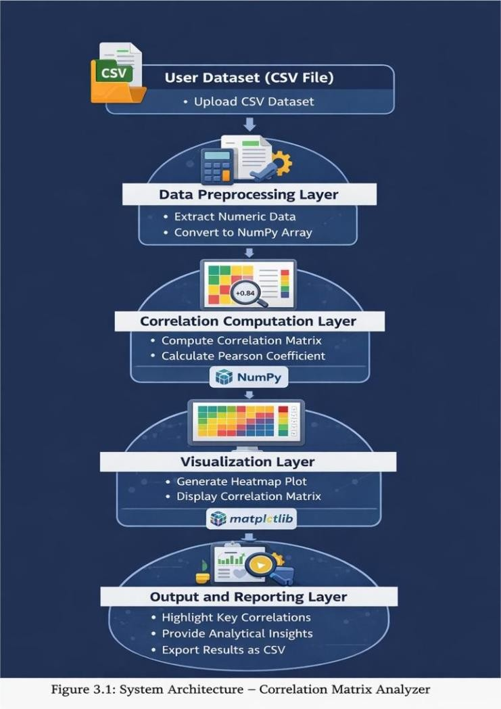

Module Description
Module 1: Dataset Input Module
This module is responsible for receiving the dataset from the user. The system accepts datasets in CSV format and loads the file into the program environment. It reads the dataset structure,

extracts column headers, and validates that the dataset contains numerical attributes suitable for correlation analysis.

Module 2: Preprocessing Module
The Data Processing Module prepares the dataset for numerical computation. It parses the CSV file and separates column names from numerical data values. The dataset is then converted into structured numerical arrays using the NumPy library.
Module 3: Correlation Computation Module
This module performs the core statistical analysis of the system. It calculates pairwise relationships between variables using the Pearson correlation coefficient. The computation involves calculating mean values, covariance between variables, and standard deviation normalization.

Module 4: Visualization Module
The Visualization Module generates graphical representations of the computed correlation matrix. A heatmap is produced to visually represent correlation strengths between variables. The heatmap is created using the Matplotlib library, with labeled axes and color intensity representing correlation magnitude.

Module 5: Dashboard Module

This module is responsible for presenting the final analytical results. It displays the correlation matrix, highlights highly correlated feature pairs based on a predefined threshold, and shows the heatmap visualization to the user. Additionally, the module allows the correlation matrix to be exported as a CSV file for further analysis or documentation

UML DIAGRAMS

UML (Unified Modeling Language) is a standardized modeling language used to visualize, design, and document the structure and behavior of a system. It helps developers and analysts understand how different components of a system interact with each other. UML diagrams provide a graphical representation of system processes, making it easier to explain complex systems in a clear and structured way. In software development, UML diagrams are commonly used during the system design phase to represent system architecture, workflows, and relationships between different components. These diagrams help developers communicate system design effectively and ensure that all parts of the system are properly planned before implementation. There are several types of UML diagrams used in software engineering, including Use Case Diagrams, Class Diagrams, Sequence Diagrams, Activity Diagrams, and Component Diagrams.

TYPES OF UML DIAGRAMS

- USE CASE DIAGRAM

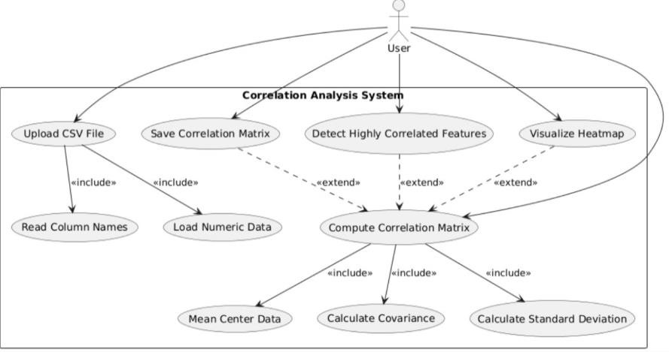

SEQUENCE DIAGRAM
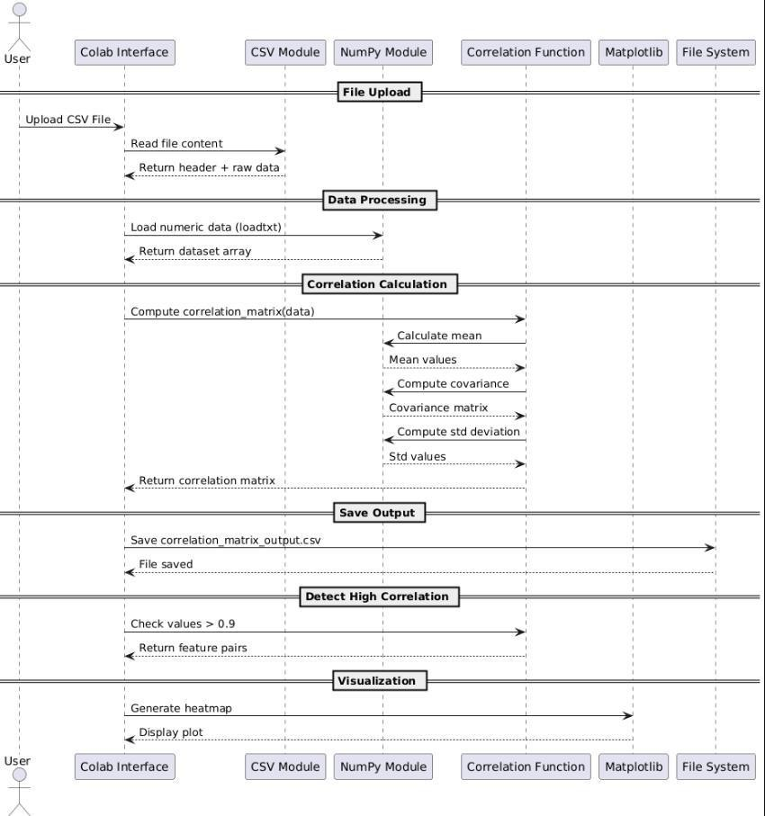

CLASS DIAGRAM

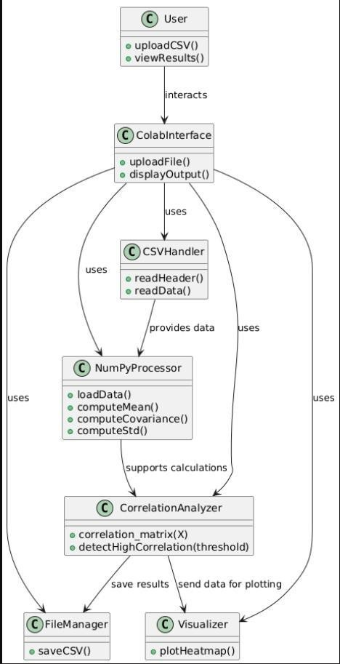

SOURCE CODE

import numpy as np
import matplotlib.pyplot as plt import csv
# import tkinter as tk # No longer needed
# from tkinter import filedialog # No longer needed from google.colab import files # For file upload in Colab import io # To read uploaded file content
print("Please upload your CSV file.") uploaded = files.upload()

if not uploaded:
print("No file selected.") exit()

# Get the first uploaded file's name and content file_name = next(iter(uploaded))
file_content = uploaded[file_name].decode('utf-8')

print("Selected file:", file_name)
# Use io.StringIO to treat the uploaded content as a file with io.StringIO(file_content) as f:
reader = csv.reader(f) header = next(reader)

print("Columns:", header)

# Use io.StringIO again for numpy.loadtxt

data = np.loadtxt(io.StringIO(file_content), delimiter=",", skiprows=1) print("Dataset shape:", data.shape)
def correlation_matrix(X):

# Mean center the data mean = np.mean(X, axis=0) centered = X - mean

# Covariance matrix
cov = np.dot(centered.T, centered) / (X.shape[0] - 1) # Standard deviations
std = np.sqrt(np.diag(cov)) # Outer product
std_matrix = np.outer(std, std) # Correlation matrix
corr = cov / std_matrix return corr
corr_matrix = correlation_matrix(data) print("\nCorrelation Matrix:") print(corr_matrix)
np.savetxt("correlation_matrix_output.csv", corr_matrix, delimiter=",") print("\nCorrelation matrix saved as correlation_matrix_output.csv") threshold = 0.9
print("\nHighly Correlated Features (>0.9):") for i in range(len(corr_matrix)):
for j in range(i + 1, len(corr_matrix)): if abs(corr_matrix[i][j]) > threshold:
print(f"{header[i]} <-> {header[j]} : {corr_matrix[i][j]:.2f}") plt.figure(figsize=(8,6))
plt.imshow(corr_matrix)

plt.xticks(range(len(header)), header, rotation=45) plt.yticks(range(len(header)), header) plt.title("Correlation Matrix Heatmap") plt.colorbar()
# Write correlation values in cells for i in range(len(corr_matrix)):
for j in range(len(corr_matrix)): plt.text(j, i, f"{corr_matrix[i,j]:.2f}",
ha="center", va="center", color="black") plt.tight_layout()
plt.show()

RESULTS / OUTPUT

Overview of Results
This chapter presents the key results and outputs generated by the Correlation Matrix Calculator project.

Output Screenshots
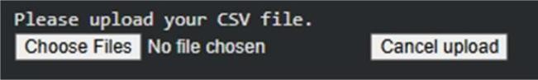
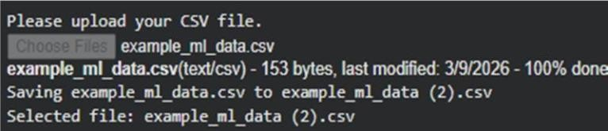
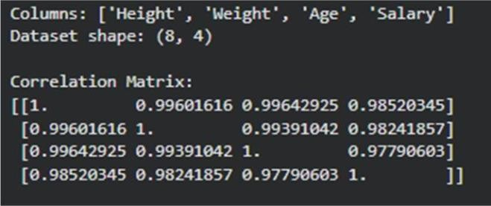
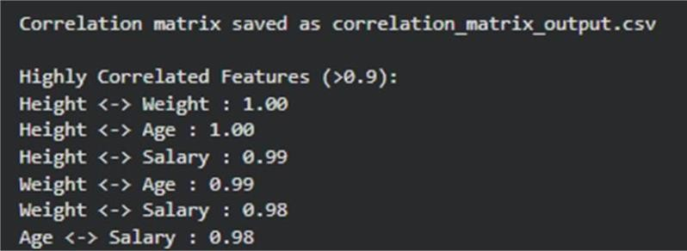

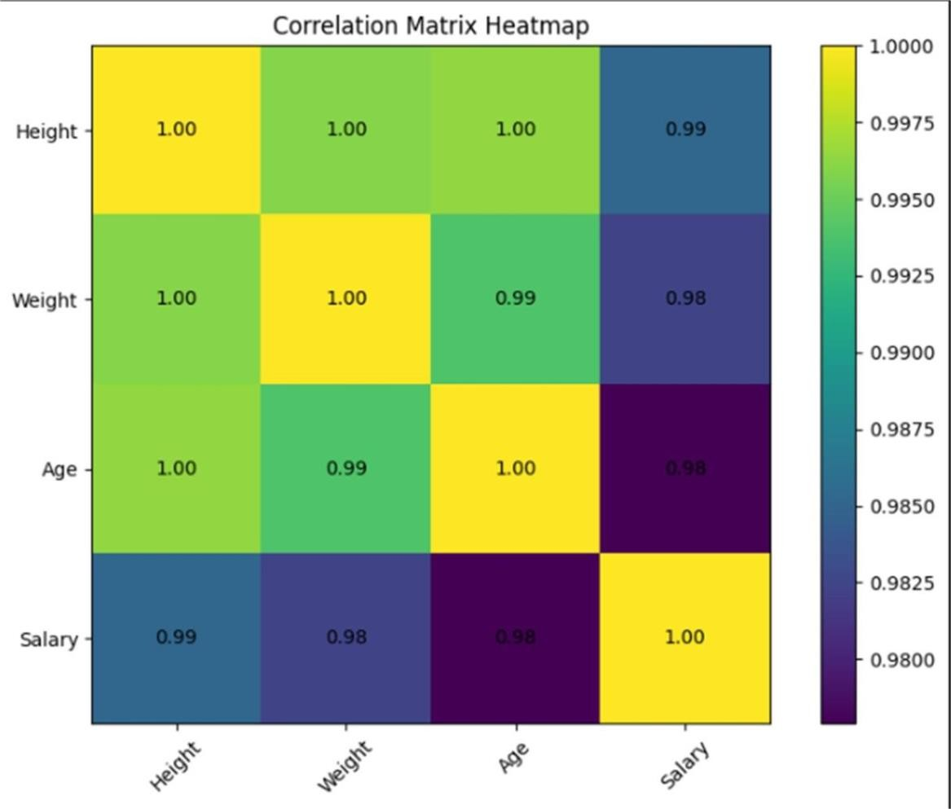

TESTING AND VALIDATION

Testing Methodology
The testing and validation of the Correlation Matrix Calculator project was performed to ensure the correctness, completeness, and reliability of the analytical pipeline. Testing was carried out at multiple stages of the project, including data loading, preprocessing, analysis, and visualization.

Unit Testing
Each function and processing step was individually tested to verify correct behavior:
    - The data loading function was validated by confirming the expected number of rows (8,807) and columns (12) after import.
    - Missing value counts were cross-verified against the original dataset specifications.
    - Feature engineering functions were tested by manually inspecting a sample of derived values against their source columns.
    - Data type conversion was verified by checking df.dtypes before and after the transformation.

Integration Testing
Integration testing verified that each layer of the pipeline correctly received and processed outputs from the preceding layer:
    - The preprocessed DataFrame was verified to have zero null values in critical columns post-cleaning.
    - Analytical computations were verified by cross-checking value counts against manual sample counts.
    - Visualization outputs were checked to confirm they accurately reflected the underlying DataFrame values.

Validation of Results
The analytical results produced by the Correlation Matrix Analyzer were validated by comparing the computed correlation values with standard statistical implementations and expected

calculations performed by the system are accurate and consistent with established statistical methods.

The following validation checks were performed:

    - The computed correlation matrix values were verified to ensure they lie within the valid range of -1 to +1, which is a fundamental property of the Pearson correlation coefficient.

    - The diagonal elements of the correlation matrix were validated to confirm that each variable has a perfect correlation with itself, resulting in a value of 1.0 for all diagonal entries.

    - The results generated by the custom correlation computation algorithm were compared with the built-in correlation functions available in numerical libraries such as NumPy, confirming that both approaches produce consistent results.

These validation steps confirm that the system accurately computes correlation relationships and provides reliable visual representations of dataset variable dependencies.

Testing Summary Table

Test Case | Description | Expected | Status
TC-01: Data Loading | Verify CSV loads with correct shape | 8807 rows, 12 cols | PASS
TC-02: Missing Values | Confirm null values handled correctly | Zero nulls in key cols | PASS
TC-03: Deduplication | Remove duplicate records | No duplicates remain | PASS
TC-04: Type Conversion | date_added parsed as datetime | dtype = datetime64 | PASS
TC-05: Feature Engineering | year_added/month_added derived | Correct year/month values | PASS
TC-06: Visualization | Charts render with correct data | Values match DataFrame | PASS
Table 9.1: Testing and Validation Summary

ADVANTAGES

Advantages of the Project
The Correlation Matrix Analyzer project offers several important advantages in the field of data analysis and exploratory data analysis (EDA). The key benefits of the system are described below:
- Cost-Effective Analysis: The project utilizes open-source technologies such as NumPy and Matplotlib, eliminating the need for expensive proprietary statistical software. All tools used in the project are freely available and widely supported by the data science community.

- Flexible Dataset Support: The system is designed to work with any CSV dataset containing numerical attributes. This flexibility allows users to analyze datasets from various domains such as finance, healthcare, business analytics, and scientific research.

- Efficient Numerical Computation: The use of numerical computing libraries ensures fast and efficient correlation calculations even for moderately large datasets.

- Clear Data Visualizations: The project provides heatmap visualizations of correlation matrices, enabling users to quickly interpret relationships between variables.

- Detection of Feature Relationships: The system automatically identifies highly correlated feature pairs based on a predefined threshold. This helps users detect redundant variables or potential multicollinearity issues that may impact statistical analysis or machine learning models.

- Reusable Analytical Framework: The framework developed in this project can easily be extended or modified for additional data analysis tasks. It can serve as a foundation for more advanced analytical systems, including feature selection tools and machine learning preprocessing pipelines.

LIMITATIONS

11.1 Limitations of the Project
The following limitations are acknowledged in the scope and implementation of the Correlation Matrix Analyzer project:
- Numerical Data Dependency: The system primarily performs correlation analysis on numerical data. Datasets containing categorical or textual attributes require preprocessing or conversion before they can be included in correlation calculations.

- Linear Relationship Analysis Only: The system computes correlations using the Pearson correlation coefficient, which measures only linear relationships between variables. Non-linear relationships between variables may not be effectively captured..

- Limited Data Preprocessing: The current implementation performs basic dataset reading and numerical conversion but does not include advanced preprocessing techniques such as missing value imputation, normalization, or categorical encoding.

- No Predictive Modeling: The scope of the project is limited to correlation-based exploratory data analysis. It does not include predictive machine learning models, regression analysis, or advanced statistical inference techniques.

- Dataset Size Constraints: The system is designed primarily medium-sized datasets. Extremely large datasets require more advanced data processing frameworks or distributed computingsystems.

APPLICATIONS

12.1 Applications of the Project
The Correlation Matrix Analyzer developed in this project has several practical applications across different fields where data analysis and statistical interpretation are required. The following are key areas where the techniques and methods used in this project can be applied:

- Feature Selection in Machine Learning: Correlation analysis helps identify highly related variables in datasets. This information can be used to remove redundant features and improve the performance and efficiency of machine learning models.

- Financial Data Analysis: Financial analysts can use correlation matrices to study relationships between variables such as stock prices, market indices, and economic indicators to support investment decisions and risk analysis.

- Business and Market Analysis: Businesses can analyze relationships between factors such as sales, marketing expenditure, customer behavior, and revenue to gain insights that support strategic planning and decision-making.

- Academic Research: The methodology and findings contribute to academic research in digital media studies, entertainment economics, and data-driven cultural analytics.

- Healthcare and Medical Data Analysis: Medical researchers can use correlation analysis to explore relationships between clinical variables, patient characteristics, and health outcomes to support medical studies and healthcare analytics.

FUTURE SCOPE

Data Enhancement

Integration of Real-Time Data
A major enhancement to this project would be the integration of real-time datasets through APIs or automated data pipelines. Instead of manually uploading CSV files, the system could retrieve data directly from online databases or web services. Real-time data integration would allow the correlation analysis tool to continuously analyze updated datasets and provide dynamic insights as new data becomes available.

Multi-Dataset Integration
Another potential improvement is the ability to combine and analyze multiple datasets simultaneously. By integrating datasets from different domains or sources, users could explore broader relationships between variables and perform more comprehensive analytical studies. This enhancement would allow the system to compare correlations across multiple datasets and provide deeper analytical insights.

Additional Data Attribute Support
Future improvements may also include support for preprocessing and transforming non-numerical attributes.

Advanced Analytics

Predictive Modeling Integration
Building on the correlation analysis foundation of this project, future work could incorporate machine learning models that use correlation insights for predictive analysis. Variables identified as significant through correlation analysis could be used as features for building predictive models such as regression or classification systems.

Advanced Statistical Analysis
Future development may include additional statistical techniques beyond correlation analysis. Methods such as regression analysis, hypothesis testing, and dimensionality reduction techniques like Principal Component Analysis could be implemented to provide deeper analytical capabilities.

Technology Enhancement

Interactive Visualization Dashboard

Future versions of the system could include interactive dashboards where users can dynamically explore correlation results. Technologies such as web-based visualization frameworks could allow users to filter variables, zoom into heatmaps, and interactively explore relationships within datasets.
Automated Data Analysis Pipeline
Another technological enhancement would involve automating the entire analysis workflow. The system could automatically load datasets, perform correlation computations using libraries such as NumPy, generate visualizations using Matplotlib, and produce reports without requiring manualintervention.

CONCLUSION
This mini project successfully developed and implemented a Correlation Matrix Analyzer capable of analyzing relationships between numerical variables in user-provided datasets. The project followed a structured data analysis workflow that included dataset input, data preparation, statistical computation, visualization, and result interpretation. Through this systematic approach, the project demonstrates how statistical techniques can be applied to extract meaningful insights from raw datasets.

The system was implemented using the Python programming language along with widely used data science libraries such as NumPy and Matplotlib. These tools enabled efficient numerical computations and clear graphical visualization of correlation relationships within datasets. The application allows users to upload datasets in CSV format, compute correlation matrices, detect highly correlated variables, and generate heatmap visualizations for easier interpretation.

The analysis performed by the system is based on the Pearson correlation coefficient, which measures the strength and direction of linear relationships between variables. The resulting correlation matrix provides values ranging from -1 to +1, where strong positive or negative values indicate significant relationships between variables. The generated heatmap visualization further enhances understanding by presenting these relationships in an intuitive graphical format.

The project demonstrates the importance of correlation analysis in Exploratory Data Analysis (EDA), particularly for identifying dependencies between variables and detecting redundant features in datasets. Such insights are valuable in many fields including data science, finance, research analytics, and machine learning, where understanding relationships between variables is essential for building accurate models and making informed decisions.

In conclusion, the Correlation Matrix Analyzer provides a simple, efficient, and flexible tool for performing correlation-based data analysis. The project highlights the practical application of statistical methods and visualization techniques in real-world data analysis tasks.

REFERENCES / BIBLIOGRAPHY

References

Books and Textbooks

  - McKinney, W. (2017). Python for Data Analysis: Data Wrangling with Pandas, NumPy, and IPython (2nd ed.). O’Reilly Media.
  - VanderPlas, J. (2016). Python Data Science Handbook: Essential Tools for Working with Data. O’Reilly Media.
  - Grus, J. (2015). Data Science from Scratch: First Principles with Python. O’Reilly Media.
  - Tukey, J. W. (1977). Exploratory Data Analysis. Addison-Wesley.
  - Cairo, A. (2016). The Truthful Art: Data, Charts, and Maps for Communication. New Riders.
  - Few, S. (2009). Now You See It: Simple Visualization Techniques for Quantitative Analysis. Analytics Press.
  - Wickham, H., & Grolemund, G. (2017). R for Data Science. O’Reilly Media.
  - Hastie, T., Tibshirani, R., & Friedman, J. (2009). The Elements of Statistical Learning. Springer.
  - James, G., Witten, D., Hastie, T., & Tibshirani, R. (2013). An Introduction to Statistical Learning with Applications in R. Springer.
  - Provost, F., & Fawcett, T. (2013). Data Science for Business. O’Reilly Media.
  - Bishop, C. M. (2006). Pattern Recognition and Machine Learning. Springer.
  - Han, J., Kamber, M., & Pei, J. (2012). Data Mining: Concepts and Techniques (3rd ed.). Morgan Kaufmann.
  - Lobato, R. (2019). Netflix Nations: The Geography of Digital Distribution. New York University Press.

Research Papers and Articles

  - Gomez-Uribe, C. A., & Hunt, N. (2015). The Netflix Recommender System: Algorithms, Business Value, and Innovation. ACM Transactions on Management Information Systems, 6(4), 1–19.
  - Hallinan, B., & Striphas, T. (2016). Recommended for You: The Netflix Prize and the Production of Algorithmic Culture. New Media & Society, 18(1), 117–137.
  - Amatriain, X., & Basilico, J. (2012). Netflix Recommendations: Beyond the 5 Stars.
Netflix Tech Blog.
  - Lops, P., de Gemmis, M., & Semeraro, G. (2011). Content-based Recommender Systems: State of the Art and Trends. Recommender Systems Handbook, 73–105.
  - Chandrashekar, A., Amat, F., Basilico, J., & Jebara, T. (2017). Artwork Personalization at Netflix. Proceedings of the 11th ACM Conference on Recommender Systems.
  - Breiman, L. (2001). Random Forests. Machine Learning, 45(1), 5–32.
  - Friedman, J. H. (2001). Greedy Function Approximation: A Gradient Boosting Machine.
Annals of Statistics, 29(5), 1189–1232.

Online Resources and Documentation

  - Shivam Bansal. (2021). Netflix Movies and TV Shows Dataset. Kaggle. Retrieved from https://www.kaggle.com/datasets/shivamb/netflix-shows
  - Pandas Documentation. (2023). Retrieved from https://pandas.pydata.org/docs/
  - Matplotlib Documentation. (2023). Retrieved from https://matplotlib.org/stable/contents.html
  - Seaborn Documentation. (2023). Retrieved from https://seaborn.pydata.org/
  - NumPy Documentation. (2023). Retrieved from https://numpy.org/doc/
  - Python Software Foundation. (2023). Python Language Reference. Retrieved from https://docs.python.org/3/
  - Netflix Investor Relations. (2023). Netflix, Inc. Q4 2023 Letter to Shareholders. Retrieved from https://ir.netflix.net/
  - Kaggle Documentation. (2023). Retrieved from https://www.kaggle.com/docs
  - Towards Data Science. (2023). Articles on Data Analysis and Machine Learning. Retrieved from https://towardsdatascience.com
  - Analytics Vidhya. (2023). Data Science Tutorials and Guides. Retrieved from https://www.analyticsvidhya.com

APPENDIX

A. Dataset Description
The dataset used in this project is a user-provided CSV dataset containing numerical variables for statistical analysis. The dataset can originate from various domains such as finance, health, education, or business analytics. The system reads the dataset using Python and processes it to compute correlations between numerical attributes.

The primary purpose of the dataset in this project is to allow the Correlation Matrix Calculator to identify relationships between variables using statistical correlation techniques. The dataset structure typically contains multiple rows representing observations and multiple columns representing variables or features. These variables are analyzed to determine the strength and direction of relationships between them.

B. Dataset Column Definitions

Column Name | Data Type | Description
type | Integer / Float | Quantitative variables used for correlation computation
Identifier Column | String / Integer | Optional column representing record identifiers
Categorical Columns | String | Non-numerical attributes that are ignored in correlation analysis

D. Abbreviations and Acronyms

Abbreviation | Full Form
EDA | Exploratory Data Analysis
CSV | Comma-Separated Values
CRISP-DM | Cross-Industry Standard Process for Data Mining
NLP | Natural Language Processing
API | Application Programming Interface
B.Tech | Bachelor of Technology
CSE | Computer Science and Engineering
DS | Data Science

Abbreviation | Full Form
JNTUH | Jawaharlal Nehru Technological University Hyderabad
UGC | University Grants Commission
AICTE | All India Council for Technical Education
NAAC | National Assessment and Accreditation Council
NBA | National Board of Accreditation

